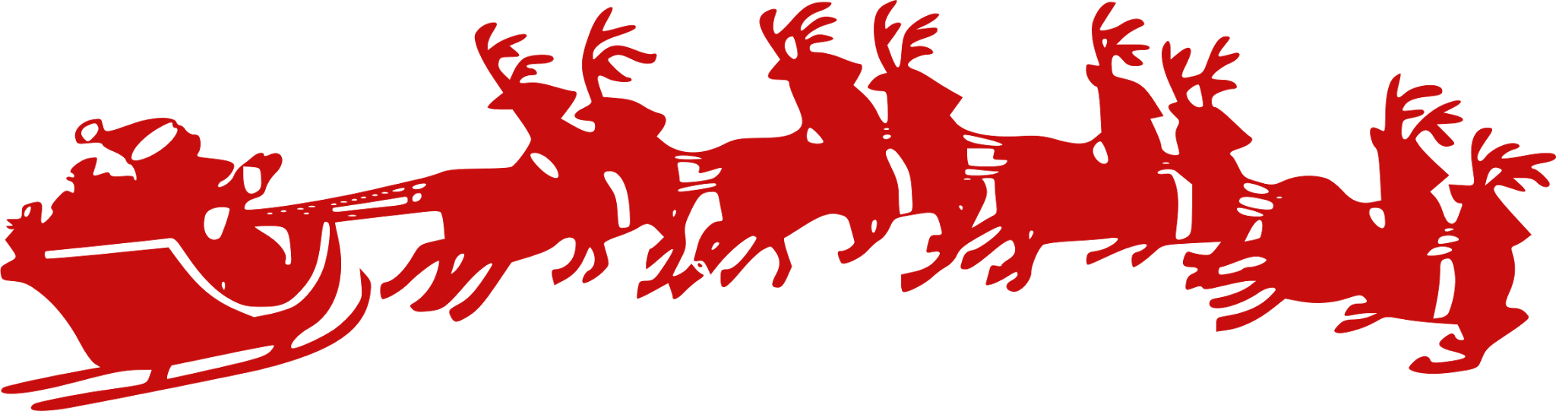
Santa’s Village Craft Show
Sponsored by Eats & Sweets*
*Entrepreneur class at Oil City High School
Friday, December 15, 2017
3:00pm-7:00pm
- At the Oil City High School Library
10 Lynch Blvd.,Oil City, PA 16301
- Chinese Auction
  - Proceeds go to Jamie’s Kids
- Many Vendors
  - with variety of shopping choices
- Food and Beverages
  - Baked Potato Bar, Snacks, and Beverages
- Santa will be attending from 4:00-6:00 pm
  - Pictures will be taken
(Prices will vary from $3-$5)
Pictures may be picked up at OCHS office on December 20th; pictures may be mailed for small fee; details day of event and allow 1-2 weeks for processing/delivery)

Come down and get into the holiday spirit! Help support your local Oil City Entrepreneur class, Community Entrepreneurs, and raise money for Jamie’s kids.
Questions: Email Hannah Lamberton @ hannahlamberton@student.ocasd.org

