CHARITABLE DEEDS
“ALL YOU CAN EAT”
SPAGHETTI DINNER

SAT. NOVEMBER 10, 2018
DINNER TIME: 3:30 -7PM
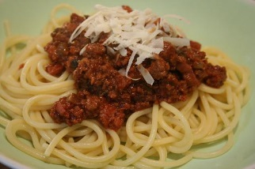
*TAKE OUTS AVAILABLE*

JOHN’S SECRET SPAGHETTI SAUCE
SPAGHETTI
ITALIAN BREAD
APPLE SAUCE
DESSERT
DRINK

LOCATION: PRICE -
WOLFS DEN ADULTS: $8.00
308 TIMBERWOLF RUN CHILDREN 10 AND UNDER: $5.00
KNOX PA 16232 CHILDREN 2 AND UNDER: FREE
INFORMATION: 814-797-0286

100% OF WHAT IS RAISED HELPES
THE POOR AND NEEDY IN THE COMMUNITY
WITH THEIR UTILITIES.

